

TED UNIVERSITY
Faculty of Engineering
Department of Software Engineering

SENG 399 – Summer Internship Report
by
Name SURNAME

Company
Internship Date (from … to…)
Submission Date

Table of Contents
Table of Contents 2
1 Introduction 3
1.1 Overall Goal 3
1.2 Expected Learning Outcomes (LOs) 3
2 The Company Information 3
2.1 General 4
2.1.1 Historical background 4
2.1.2 Engineering Units 4
2.2 Products and Services 4
2.3 Work Environment 4
3 Assigned Tasks and Projects 4
3.1 Problem Definition 4
3.2 Knowledge Integration 5
3.2.1 Knowledge Integration with Course Work 5
3.2.2 Learned Tools and Technologies 5
3.2.3 Self-Learning 5
3.3 Work Plan and Timeline 5
3.4 Implementation 5
3.4.1 Literature review and Data Collection 5
3.4.2 Implementation 5
3.5 Evaluation & Impact Analysis 5
4 Conclusions & Recommendations 5
5 References 6

Introduction

Overall Goal
A simple, clear, brief, positive, and correctly written statement, that describes the "big-picture" idea of why the student is interested to have training, what he wants to focus on, and what he needs to accomplish.

New paragraph comes here.....


Figure 1: Figure example. Give figure explanation. Image is taken from [1].

Expected Learning Outcomes (LOs)
Three or more correctly written learning outcomes that describe specific, measurable, and realistic achievements to accomplish during the training experience. They relate to the job, represent the job functions and duties, assist in professional growth and development, relate to the student's course of study or major, and help to reach the overall goal of student's training experience. Please be aware that this section should rely not only the below written (see Fig. 1) LOs on but also your own expectations from this summer practice.

LO | Description
LO1 | Communicate with technical and non- technical people orally and in writing to share knowledge.
LO2 | Interpret foundational scientific, engineering, management and artistic concepts and principles.
LO3 | Apply mathematical, statistical, computing and engineering concepts and tools to model and solve problems.
LO4 | Follow current trends and developments in their fields to adapt to the changing environment, with and without guidance.
LO5 | Act professionally by following social, ethical and cultural responsibilities.
LO6 | Design and implement a computer system, be it software or hardware or both, to serve specific needs in an efficient, interdisciplinary team work context.
LO7 | Evaluate feasible solutions to complex engineering projects, based on economic, social and ethical constraints.
Figure 1 Learning Outcomes

The Company Information
This section includes general information about the company together with products and services it provides and the work environment that the student worked in.

General
Address of the company. Name, background and contact information of the supervisor.

Historical background
Correctly written short description of the company/ establishment history.
........

Engineering Units
Engineering units are described in details with their functions and organizational structure.
................

Products and Services
….

Work Environment
Physical conditions of the environment, number of people working in the room can be given here.

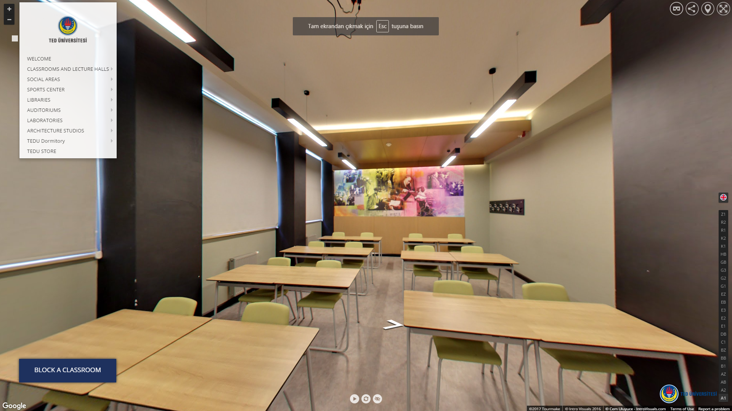
Figure 2: Figure example. Give figure explanation. Image is taken from [2]. Please refer to figures by their number (i.e., please see Figure 1 or “as explained in Fig. 1”). Do not refer to figures as "the figure below" or "the figure above." Referring to your figures is mandatory. Place the figure close as possible to the part of text referencing it. Centre the image.

Assigned Tasks and Projects

Problem Definition
The nature of the activities carried out by the department(s) or unit(s) where the major part of the training experience took place, is clearly described. Whether the function of the department is design, maintenance, R&D, project management, or anything else, the student is able to relate it to the activities of the whole company / establishment.

New paragraph comes here....

Knowledge Integration
This section explains the details of the knowledge integration with course work, learned tools and technologies together with the self-learning of the student.

Knowledge Integration with Course Work
…

Learned Tools and Technologies
…

Self-Learning
…

Work Plan and Timeline
Task | Start | End | Duration
Task 1 | 15.06.2017 | 21.06.2017 | 1 week
Task 2 | 22.06.2017 | 28.06.2017 | 1 week
Task 3 | 29.06.2017 | 05.07.2017 | 1 week
Task 4 | 06.07.2017 | 13.07.2017 | 1 week
Table 1: Table example. Give table explanation.

Here you can create the corresponding Gantt chart for Table 1.

Implementation
This section discusses the actual implementation details together with corresponding literature review and data collection.

Literature review and Data Collection
…

Implementation

Evaluation & Impact Analysis

Conclusions & Recommendations
Achievement of Expected LOs, recommendations to enhance future training in this company together with ethical issues and finally the recommendations to enhance future training of TEDU engineering students are discussed in this section. You can either use separate subsections or you can mention all subtopics in a single section.

References
[1]: Code image. (Access date: 2017, June 15). Retrieved from http://dailygenius.com/tag/code/
[2]: TEDU Prospective Students. (Access date: 2017, June 15). Retrieved from https://aday.tedu.edu.tr/tr/aday

